**Compatibility**: The Tacx NEO T2 2875 is compatible with a wide range of cycling apps and software platforms, including popular options like Zwift, TrainerRoad, and Rouvy. It supports both ANT+ and Bluetooth Smart protocols, ensuring seamless connectivity with various devices such as smartphones, tablets, and cycling computers.

**Data Metrics**: The trainer provides comprehensive real-time data metrics to cyclists, including power output (in watts), cadence (pedal revolutions per minute), speed, distance traveled, and virtual gradient. These metrics are transmitted wirelessly to compatible devices for analysis and tracking during training sessions.

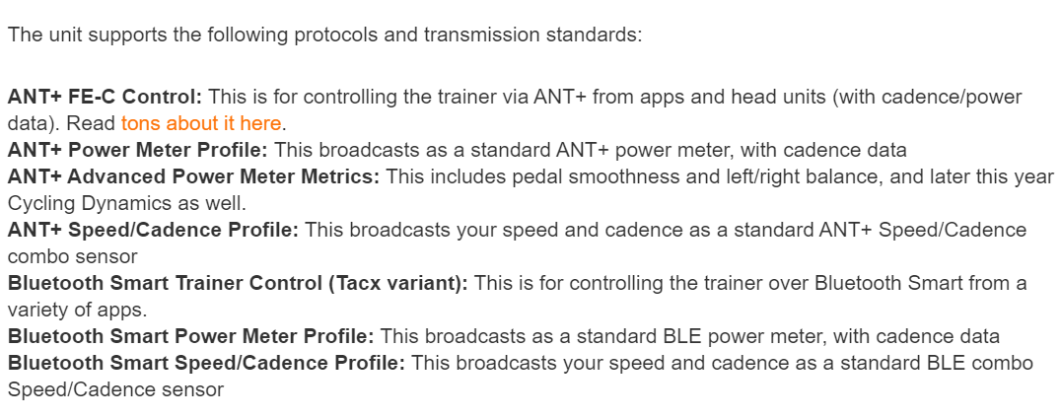taget fra:

<https://www.dcrainmaker.com/2019/11/tacx-neo-2t-smart-trainer-in-depth-review.html>

Hvad kan vi bruge these specifikationer til:

* **ANT+ FE-C Control**: This feature allows the trainer to be controlled by apps or head units using the ANT+ protocol. This means you can adjust resistance or simulate different riding conditions (such as hills) within the game based on the data received from the trainer.
* **ANT+ Power Meter Profile**: The trainer broadcasts data as a standard ANT+ power meter, providing information on power output. This data can be used to determine how fast the bicycle is "riding" in the game.
* **ANT+ Advanced Power Meter Metrics**: Metrics like pedal smoothness and left/right balance can add realism to the game's simulation. For example, if the user is pedaling unevenly or with poor technique, it could affect the performance of the virtual bicycle in the game.
* **ANT+ Speed/Cadence Profile**: This profile broadcasts speed and cadence data, which can be used to calculate the virtual speed of the bicycle in the game and adjust it accordingly.
* **Bluetooth Smart Trainer Control (Tacx variant)**: Similar to ANT+ FE-C Control, this feature allows the trainer to be controlled over Bluetooth Smart. This expands the compatibility of the trainer with different apps and devices.
* **Bluetooth Smart Power Meter Profile**: Similar to the ANT+ Power Meter Profile, this broadcasts power output data over Bluetooth Smart.
* **Bluetooth Smart Speed/Cadence Profile**: Similar to the ANT+ Speed/Cadence Profile, this broadcasts speed and cadence data over Bluetooth Smart.

Compared to other trainers:

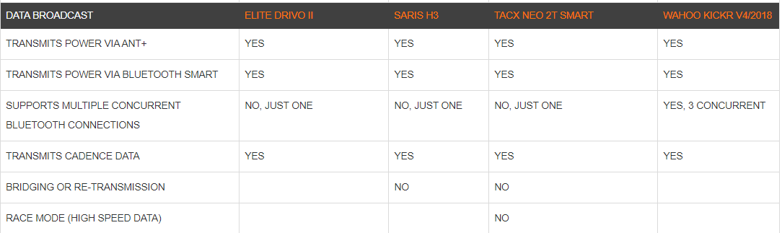

We need to retrieve the data output from the bike trainer. This could include metrics like speed, cadence, power output, pedal smoothness, left/right balance, etc.

( vi kan enten samle disse info fra Lars eller fra simulated/sample data)

Larss sample data:

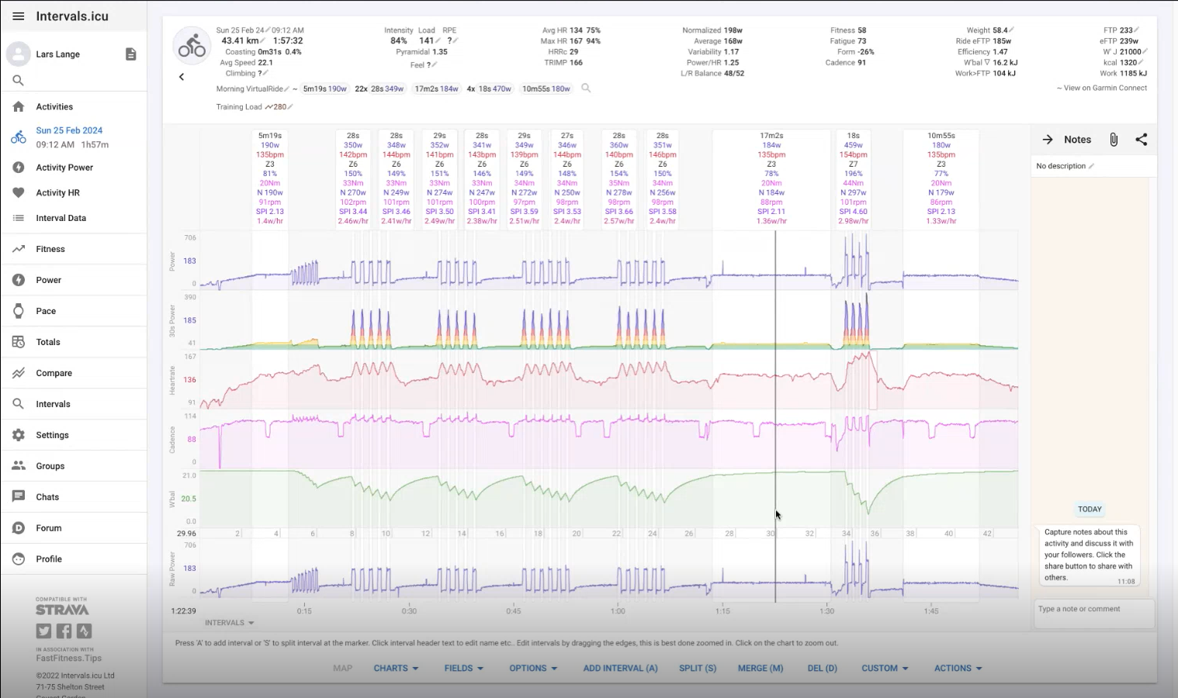

## Garmin Connect Developer Program FAQ:

<https://developer.garmin.com/gc-developer-program/program-faq/>

Fleste informationer vi har bruge for (om SDK , API ...) kan findes på: <https://developer.garmin.com/>

This guide will outline the main steps in the development of PC applications that can connect to an ANT chip or module, receive ANT messages from a specific ANT+ device, and decode this data according to its ANT+ device profile. It is assumed that you are already familiar with the [basic operation of the ANT protocol](https://www.thisisant.com/developer/ant/ant-basics) and the use of [network keys](https://www.thisisant.com/developer/resources/tech-faq/category/network-keys/).

<https://www.thisisant.com/developer/ant/starting-your-project/>

Summery:

Lars ST supporter disse data outputs:

* Speed
* Cadence
* Power output
* Pedal smoothness
* Left-right balance ...

Og Garmin connect APIs tilbyder muligheden til at integrer health og fitness data ind i vores project (training plans og workout details inkludereret)

Så vi kan sagtens bruge Lars sample data til at simulere real world scenarious i projektet. Vi skal bare se om hans sample data er compatible med de APIer vi vil integrer.

Ellers hvis vi ikke bruger Lars sample data, der eksister også nogle hjemmesider med masser af anonymized datasets . Dem kan i se neden under:

* <https://archive.ics.uci.edu/>
* <https://www.kaggle.com/>
* <https://github.com/search?q=cycling+dataset&type=repositories>
* <https://www.opendata.dk/>
* <https://ieee-dataport.org/>
* ...

Her er nogle sampledata af en persons en times zwift oplevelse per dage (average watts inkludereret) men den har ikke en record af hele den times data, den siger bare hvor mange watts hun har brugt hver eneste dage til trainingen:

<https://www.kaggle.com/code/jairusmartinez/cycling-energy-regression>

<https://public.tableau.com/app/profile/jairusmartinez/viz/PersonalStravaActivityData/Dashboard1>

Fitbit users consented to the submission of personal tracker data, including minute-level output for physical activity, heart rate, and sleep monitoring. Individual reports can be parsed by export session ID (column A) or timestamp (column B).

<https://www.kaggle.com/datasets/arashnic/fitbit>